|  |  |
| --- | --- |
| Name: | Class: |



**➀ Listen and write the number.** Score / 10

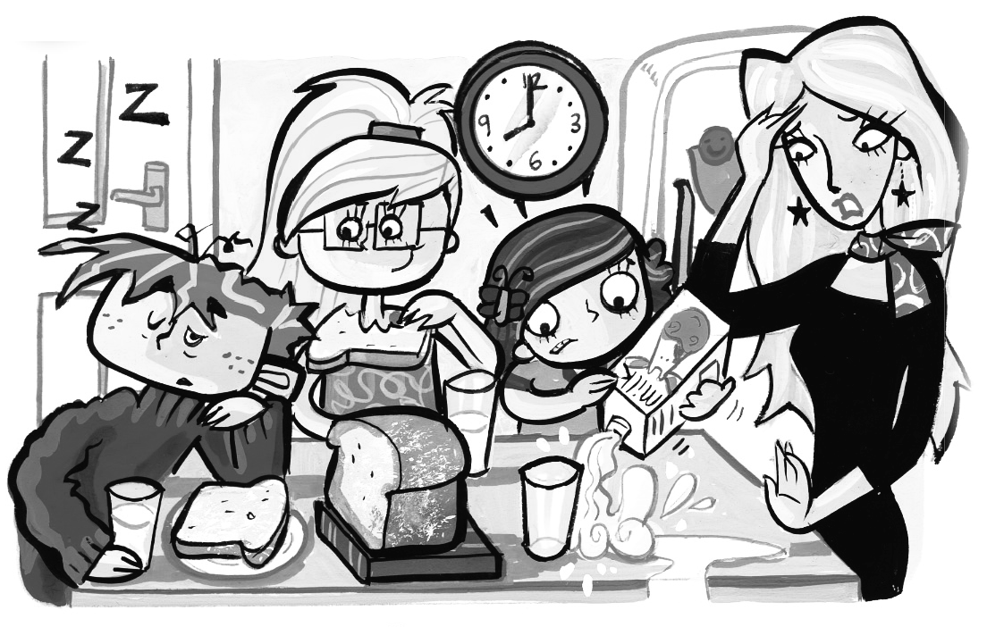



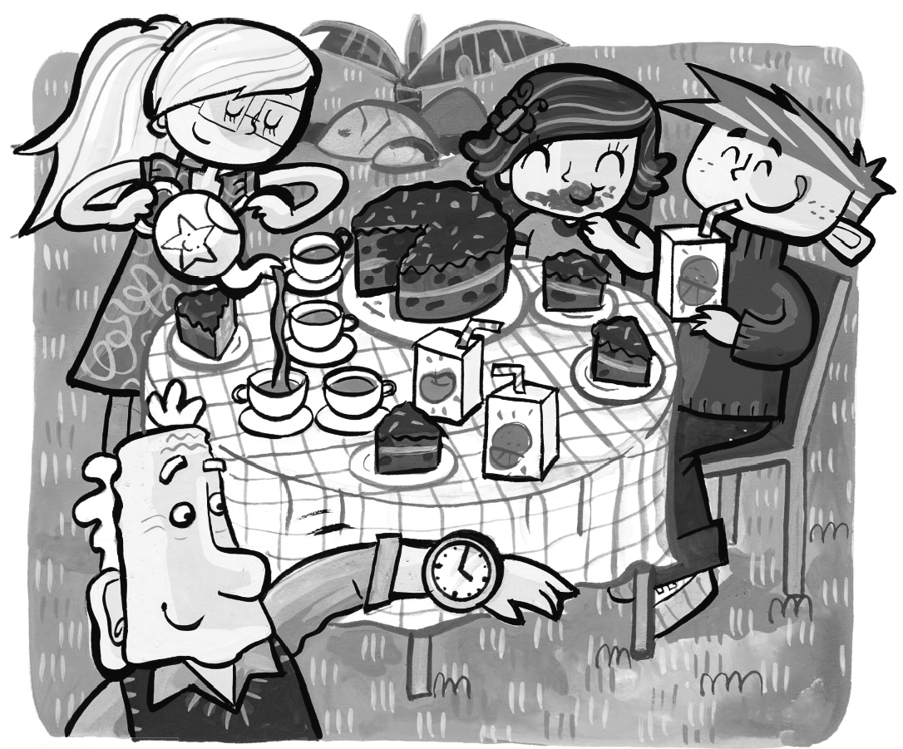





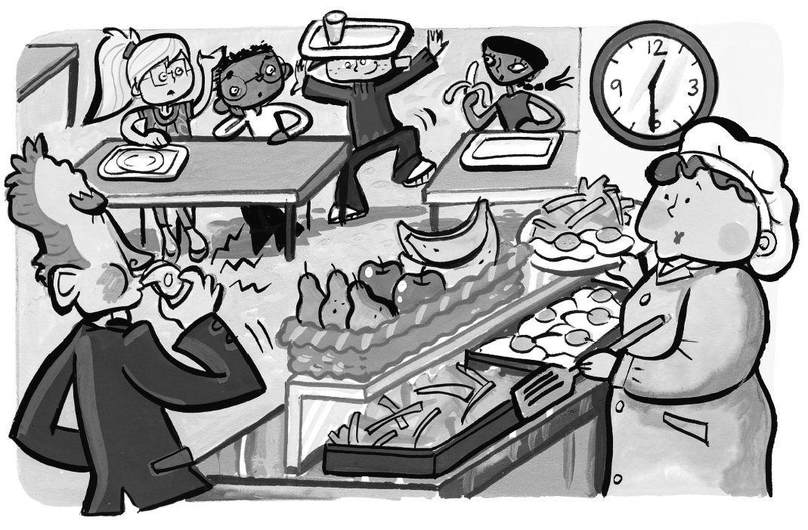



**➁Look and write.** Score / 5

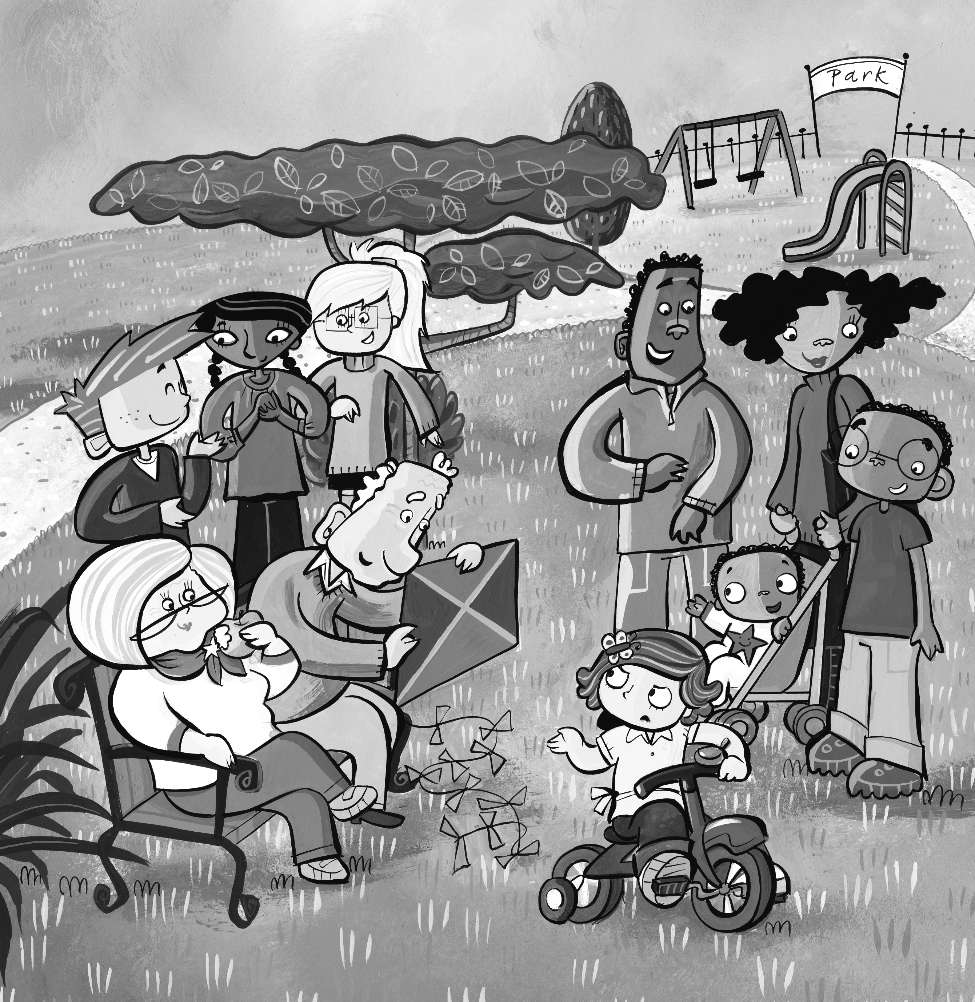➊ How many children are there? five

➋ How many babies are there? _______

➌ How many women are there? _______

➍ How many men are there? _______

➎ How many kites are there? _______

➏ How many bikes are there? _______

Total review score / 15